University of Padova,
Dept. of Information Engineering

2015 Summer School of Information Engineering,

ICT for Automotive Industry

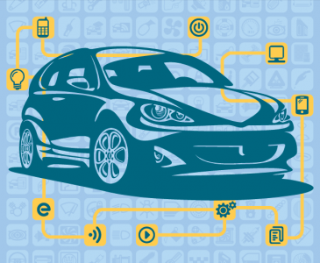

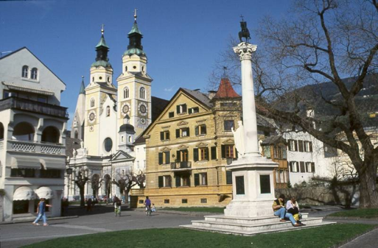

Bressanone (BZ), Italy
July 5 – 11, 2013

the co-Directors
prof. Gaudenzio Meneghesso, gauss@dei.unipd.it
prof. Silvano Pupolin, pupolin@dei.unipd.it

University of Padova, Dept. of Information Engineering
2015 Summer School of Information Engineering,
Bressanone (Brixen, BZ), Italy - July 5 – 11, 2013

ICT for Automotive Industry

Sunday 5/7 (Hotel Gruener Baum)
17:00 – 19:00 SSIE Opening, Welcome, Introduction to the school and Program description (Gaudenzio Meneghesso, Silvano Pupolin, Co-Directors).

Monday 6/7 (Casa della Gioventù)
9:00 – 13:00 Cristian Garbossa Infineon Technologies Italia S.r.l. Development Center Padova “Power Electronics for automotive”
15:00 – 18:00 PhD students working Groups

Tuesday 7/7: (Casa della Gioventù)
9:00 – 13:00 Alberto Guiotto, Davide Baccarin; Automotive Lighting Italia S.p.A; “Automotive Lighting”
15:00 – 17:00 PhD students Presentations

Wednesday 8/7: (Casa della Gioventù)
9:00 – 13:00 Prof. Dr.-Ing. Bernhard Wicht, Robert Bosch Center for Power Electronics Integrated Circuits Reutlingen University, “Automotive Smart Power IC Design”
15:00 – 18:00 PhD students working Groups

Thursday 9/7: (Casa della Gioventù)
9:00 – 13:00 Giovanni Pau, Laboratoire d'Informatique de Paris 6 (LIP6) “Vehicular communications”
15:00 – 18:00 Workshop: Reporting of the WG activity
Presentation WG1
Presentation WG2
Presentation WG3
19:30 – 22:00 Social Dinner

Friday 10/7: (Casa della Gioventù)
9:00 – 13:00 Paolo Falcone Chalmers, “Fundamentals and recent advances in vehicle platooning control”
13:00 – 13:30 SSIE Closing, (Gaudenzio Meneghesso, Silvano Pupolin, Co-Directors)

Saturday 11/7: (Hotel Gruenen Baum)
9:00 – 11:00 SSIE 2015 Final test (for those who need the 2 ECTS)

ABSTRACTS

Cristian Garbossa
Infineon Technologies Italia S.r.l. Development Center Padova
“Power Electronics for automotive”
Abstract: Automotive environment is very challenging for the electronics modules mounted in a car. According to where they are hosted, the IC should work within a huge range of temperature and should be immune of disturbances coming from the environment as ESD event and EMI, which means they should be very robust. Moreover, depending where the IC is mounted (ie EPS, airbag…), it should also prevent the system to fail and cause injury to passengers.
In this seminar it will presented an overview of the harsh environment where the electronic component is supposed to work with a deeper look of the battery that is the core of the energy storage for the electronic modules in a car. It will be discussed also briefly the quality target the automotive IC normally has to reach.
In addition this tutorial will introduced energy efficient systems that will satisfy the increased demand of CO2 reduction with special focus on power supply modules (standalone linear or switching regulators as well as System Basis Chip solution). Finally the Functional safety will be introduced describing the purpose of the ISO26262 standard and discussing the consequence in the development of the IC from process to technical solution.

Alberto Guiotto;
R&D, Automotive Lighting Italia S.p.A.
“Automotive Lighting”
Abstract: The first part of the tutorial will describe Automotive Lighting and Magneti Marelli group, with a focus on the Lighting business line. Therefore, current and future implementations in exterior lighting will be presented: Adaptive Frontlight Systems (AFS), Laser Head Lamps, Matrix High Beam Head Lamps, Intelligent LED Rear Lamps, together with several details on homologation requirements and intellectual property. The following part will include a more technical overview on the electronic design aspects inside the rear lamp, with application cases that will give examples on the real problem in the Automotive field. The last part will expose the innovation topics, as OLED rear lamp and Application Specific Standard Product (ASSP) development.”

Prof. Dr.-Ing. Bernhard Wicht,
Robert Bosch Center for Power Electronics, Integrated Circuits, Reutlingen University
“Automotive Smart Power IC Design
Abstract: Smart power ICs combine analog, digital and high-voltage / power functions in a single chip. Based on high-voltage BiCMOS technologies smart power design allows for integration of complete systems or subsystems into single chip solutions. With the adoption of more electronics, vehicles become safer, cleaner, more efficient, more comfortable, more affordable. This tutorial will give an overview of automotive design challenges and will cover the circuit design of main smart power circuit blocks like charge pumps, gate drivers, linear and switched-mode voltage regulators. System design aspects like pinout, floorplanning, grounding / supply guidelines will also be addressed.
Part I: Introduction, Power Switches, Gate Drivers and Protection
Part II: Charge Pumps, Linear and Switched-Mode Regulators, System Design

Giovanni Pau, Laboratoire d'Informatique de Paris 6 (LIP6), CNRS, Paris, France
“Vehicular communications”
Abstract: Vehicular networks have been investigated by industry and academia for over a decade yet no actual deployments are on the road today; this due to inadequate technical solutions and a vertical market that slows down innovation. Recent innovations in autonomous driving, however, are reinforcing the case for connected vehicles able to communicate both V2I and V2V in support of cooperative driving and machine-to-machine information exchange. In this talk we will take a journey through the current state of the art and research challenges in Connected Vehicles. From the initial vision of Ad-Hoc connectivity to the modern vision of an integrated M2M network able to seize connectivity opportunities as well as to take advantage of LTE infrastructure.

Paolo Falcone Chalmers University of Technology, Gothenburg Sweden
“Fundamentals and recent advances in vehicle platooning control
Abstract: The objective of this lecture is twofold: 1) introducing the fundamentals and 2) overviewing the most recent results on vehicle platooning control. The lecture is therefore organized in two parts. First, the basics of vehicle dynamics modeling and longitudinal control will be presented to formally state the platooning control problem. The string stability property will be then introduced and two important classes of string stable linear controllers will be presented and analyzed. In the second part of the lecture, recently proposed approaches will be overviewed, with emphasis on the challenges set by the inherent limitations (delays and packets drops) of wireless communication links. Experimental results will be presented, based on a three-vehicle platoon.

General info
All info can be found at: http://www.dei.unipd.it/ssie

Participation at the SSIE:
All those young researchers and PhD students who wish to participate ate the SSIE must send an e-mail to: gauss@dei.unipd.it

How to Submit a Proposal
All those young researchers and PhD students who wish to present their research activities at the Workshop, should send an email to gauss@dei.unipd.it
clearly indicating:
Name
Affiliation/Postal Address
Phone/Fax
Contact Email
Title of the Presentation
Abstract (e-mail format is also OK)
Please use English language. The deadline for submitting proposals is June 30th 2014.

Presenting your Research Activity at SSIE
Each presenter will be assigned a slot of 20 minutes, including 5 minutes for questions. All presentations will be in English.

Registration & Fee
The organizing committee decided that the School has no registration fee fro PhD students, but participants will have to pay for their travel and living expenses.
For organization purposes all the participants are invited to Register by sending an e-mail either to
gauss@dei.unipd.it
with subject: Registration to Summer School on Information Engineering 2014
clearly indicating:
Name
Affiliation/Postal Address
Phone/Fax
Contact Email

Accommodation:
As for the past years we have an agreement with Gruener Baum hotels (www.gruenerbaum.it) in Brixen which will give lodging for all the persons attending the Summer School of Information Engineering (students, teachers and accompanying persons) at discount prices (July 5th 2014 - July 10th 2014 only) (see SSIE website for details: http://www.dei.unipd.it/ssie)

Net prices
single room | 66.00 Euro per person per day (breakfast included)
double room | 51.00 Euro per person per day (breakfast included)
double room (single use) | 87.00 Euro per person per day (breakfast included)
half pension supplement | 17.00 Euro per person per day
meal | 9,00 Euro for a first course
Discount prices if staying for 3 or more nights
single room | 55.00 Euro per person per day (breakfast included)
double room | 44.00 Euro per person per day (breakfast included)
double room (single use) | 71.00 Euro per person per day (breakfast included)
Imposta di soggiorno: Euro 1,60 per person/night.
Nel prezzo compreso:
- Breakfast Grande buffet
- Entrance to swimming pool
- The BRIXENCARD

